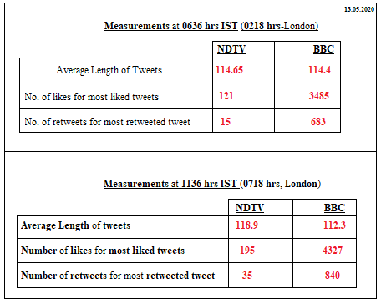

As observed from the measurements at two different time periods i.e. Morning and late Morning hours, we find that BBC, the foreign news channel is more actively tweeting about the happenings around as compared to an Indian news channel, NDTV.

Also, the people who viewed news from BBC liked and shared (retweeted) it more than its Indian counterpart, NDTV. Even though the length of BBC news is shorter than NDTV news.

**NDTV:**

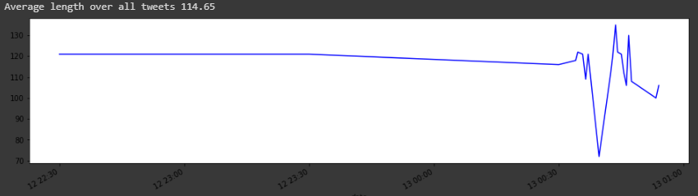

More tweet length= more expressive tweets

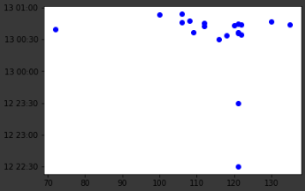

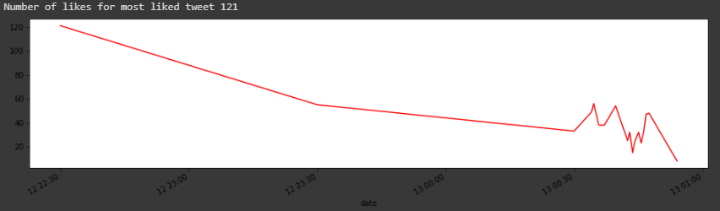

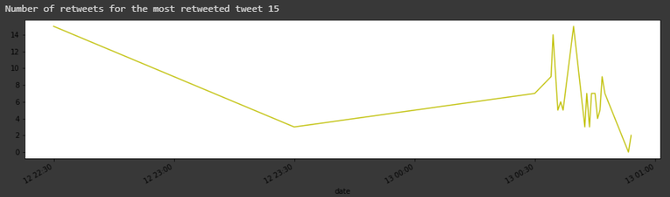

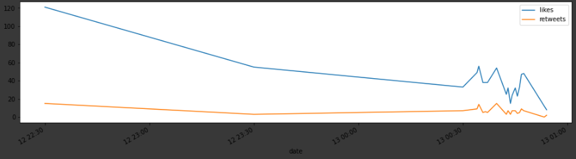

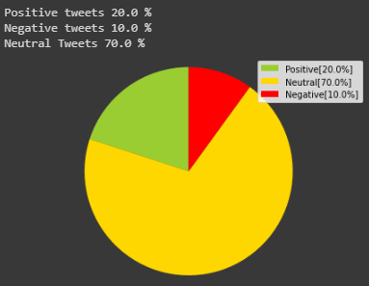

**BBC World**:

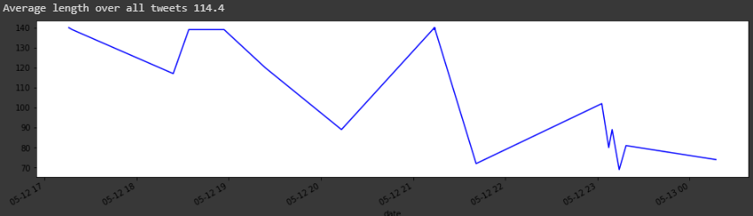

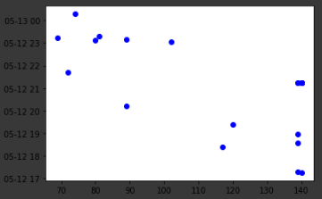

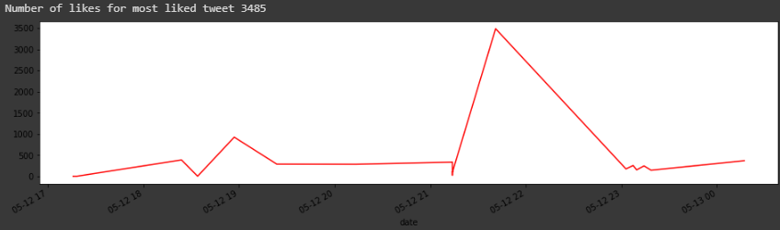

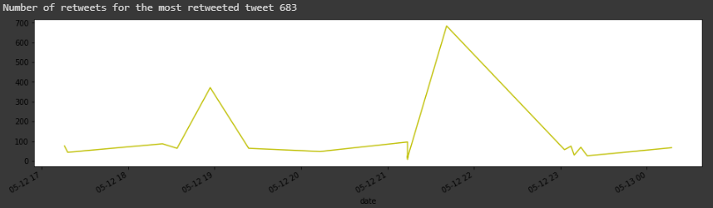

Likes vs retweets:

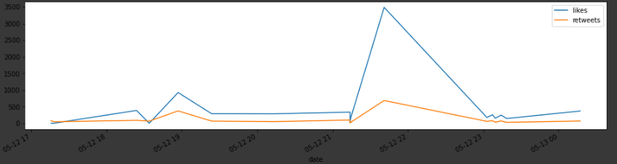

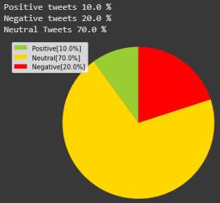

1136 hrs

**NDTV**:

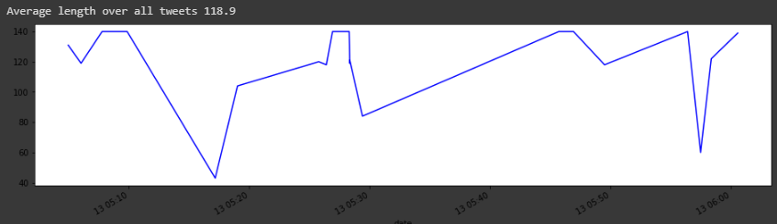

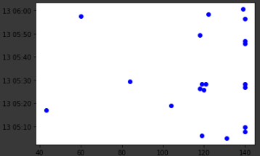

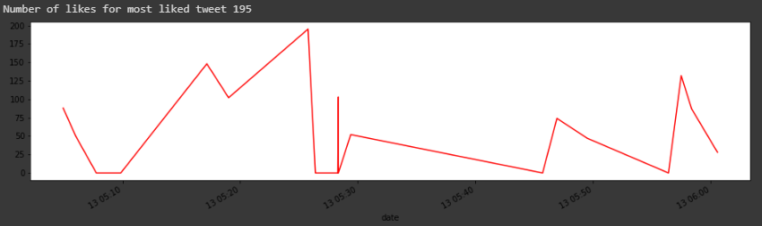

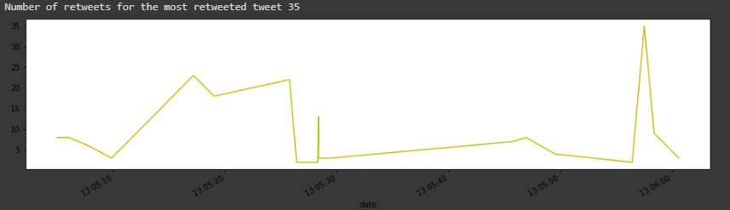

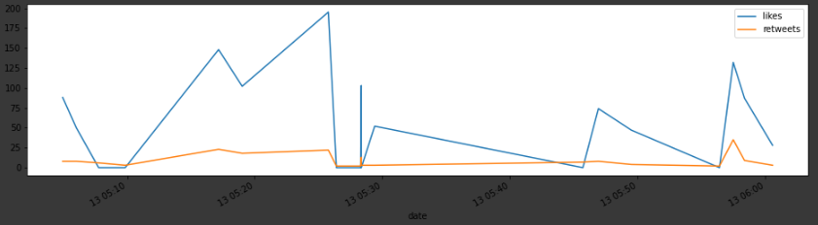

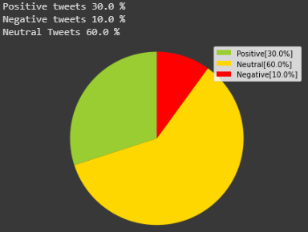

**BBC World**:

